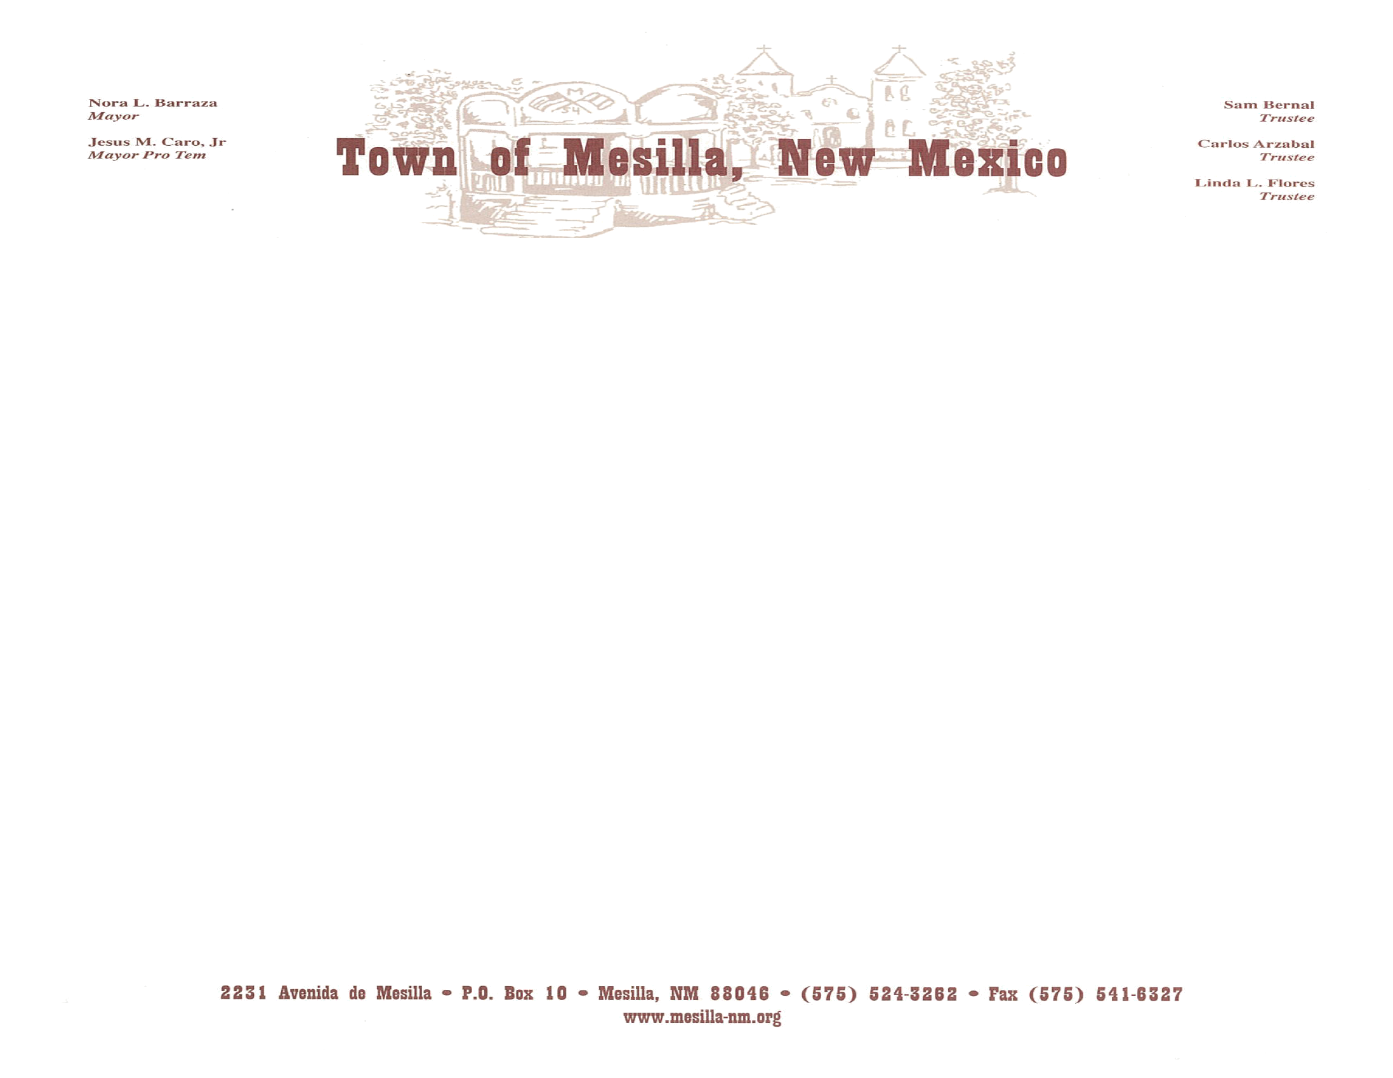

CANCELLED
THE PLANNING, ZONING AND HISTORICAL APPROPRIATENESS COMMISSION OF THE TOWN OF MESILLA HAS CANCELLED ITS REGULARLY SCHEDULED BOARD MEETING ON MONDAY, FEBRUARY 7, 2022, AT 2:30 P.M. IN THE BOARD ROOM OF THE MESILLA TOWN HALL.

THE NEXT MEETING SCHEDULED FOR THE PLANNING, ZONING AND HISTORICAL APPROPRIATENESS COMMISSION MEETING WILL BE HELD ON WEDNESDAY, FEBRUARY 9, 2022, AT 2:30 P.M.

NOTICE

Posted on 02.04.2022 at the following locations: Town Clerk’s Office 2231 Avenida de Mesilla, Public Safety Building 2670 Calle de Parian, Mesilla Community Center 2251 Calle de Santiago, Shorty’s Food Mart 2290 Avenida de Mesilla, Ristramnn Chile Co., 2531 Avenida de Mesilla and the U.S. Post Office 2253 Calle de Parian.

